ISE 5264: Modeling and Analysis of Semiconductor
Manufacturing (Fall 2024)
Term Project Phase II (Due: December 3, 2024)
OBJECTIVE
To build simulation models using AutoSched AP and AutoMod for an accelerometer production line
1. Introduction to automated material handling systems (AMHS)
Please see the introduction in Term Project Phase I, ISE 5264: Modeling and Analysis of Semiconductor Manufacturing.
2. Description of the scenario
2.1 The Whittemore Fab
The Department of Electrical and Computer Engineering (ECE) at Department at Virginia Tech has recently built a research and development fab, the Whittemore Fab. It is built to pilot test the state-of-the-art Automated Material Handling System (AMHS) manufactured by PRI Automation. The process areas and AMHS layout are shown in Figure 1. Note that the stockers and bays are located symmetrically. Inside each process bay, the tools are located in such a way that they are equidistant among each other. In addition, the tools are arranged in alphabetical order along the loop of the process bay.
The AMHS includes one inter-bay (the central loop) and four intra-bays (the smaller loops), namely, CMP, Diffusion, Etch and Lithography. There are 37 tools in this fab, 10 tools in the CMP Bay, 8 tools in the DIFF Bay, 11 tools in the ETCH Bay, and 8 tools in the LITHO Bay. The tool names and processing times are listed in Table 1. The AMHS related data are included in Table 2.
The followings are the assumptions you can make for this project.
- Each vehicle is capable of carrying one lot at a time.
- All lots are ready at the beginning and have the same priority.
- At the beginning, all lots are stored in the stocker S-CMP and all AGVs are parked at the stockers. After finishing all the tasks, all AGVs return to their original places.
- Each stocker has unlimited capacity.
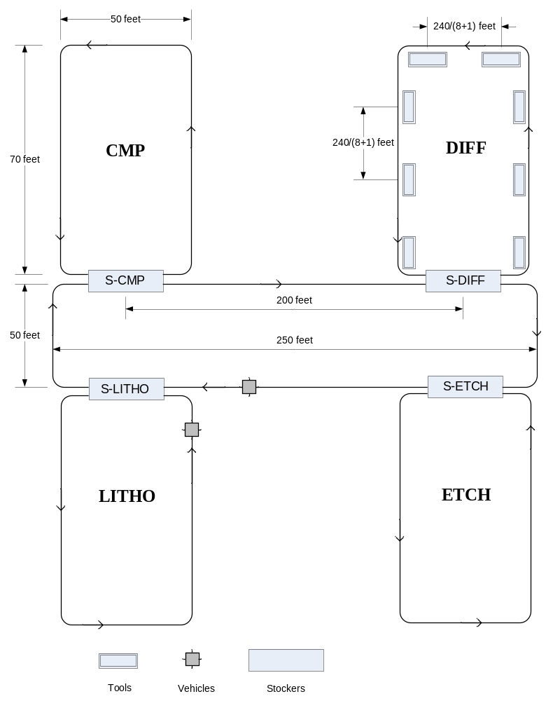
Figure 1 The process areas and the AMHS layout*
*The figure above does not show all the tools, the DIFF bay is used as an example to illustrate how tools are arranged in a bay with equal distance.
Table 1 Tool names and processing times
Workstation No. | Process Type | Process Bay | # of  Machines | Mean  Processing  Time (hours) | MTBF (hours) | MTTR  (hours)
1 | Al Clean and Deposition | CMP | 1 | 1 | 98.22 | 8.71
2 | Al Sinter | CMP | 1 | 0.5 | 60.43 | 5.28
3 | Alignment Check | CMP | 1 | 0.2 | 22.37 | 2.83
4 | Bonding | CMP | 1 | 0.5 | 58.47 | 3.12
5 | Bond-pad Opening | CMP | 1 | 0.4 | 33.31 | 1.69
6 | Cleaning | CMP | 1 | 0.4 | 41.41 | 3.23
7 | Dicing | ETCH | 1 | 0.5 | 51.51 | 1.27
8 | Dry Etch | ETCH | 1 | 2.2 | 117.22 | 9.31
9 | Dry Release Etch | ETCH | 1 | 2 | 114.33 | 8.12
10 | Dry Resist Strip | ETCH | 1 | 0.5 | 49.36 | 2.21
11 | Hard Brake | LITHO | 1 | 0.5 | 49.49 | 3.82
12 | Inspection | LITHO | 8 | 0.2 | 21.11 | 1.78
13 | Mask Exposure | LITHO | 1 | 1 | 104.34 | 9.25
14 | Measurement | LITHO | 5 | 0.2 | 22.53 | 1.66
15 | Mount Wafer | LITHO | 1 | 0.2 | 19.61 | 2.12
16 | Organic Resist Strip | DIFF | 1 | 0.5 | 55.21 | 3.22
17 | Oxide Deposition | DIFF | 1 | 1 | 121.78 | 8.91
18 | Pre Furnace Clean | DWF | 1 | 0.2 | 33.12 | 2.29
19 | Pre Fire Glass Frit | DIFF |  | 3 | 312.12 | 21.11
20 | Record Test Data | DIFF | 1 | 0.1 | 11.17 | 1.46
21 | Remove Bond-pad Strip | DIFF | 1 | 0.5 | 61.13 | 4.99
22 | Resist Coat | LITHO | 1 | 1 | 106.55 | 10.23
23 | Resist Develop | LITHO | 1 | 1 | 107.70 | 11.13
24 | Screen Printing | LITHO | 1 | 1 | 107.45 | 10.94
25 | Silicon Trench Etch | ETCH | 1 | 1 | 115.34 | 9.76
26 | Sorting | ETCH | 1 | 0.2 | 19.97 | 1.32
27 | Spin Rinse Dry | ETCH | 1 | 0.5 | 21.39 | 2.31
28 | Tape and Label | ETCH | 1 | 0.3 | 44.11 | 2.40
29 | Tape Curing | DIFF | 1 | 0.1 | 19.17 | 1.34
30 | Thermal Oxide | DIFF | 1 | 1 | 121.56 | 7.42
31 | Wafer Alignment | CMP | 1 | 0.3 | 51.01 | 2.77
32 | Wafer Probe | CMP | 1 | 0.5 | 54.02 | 3.81
33 | Wafer Scribe | CMP | 1 | 0.1 | 29.31 | 1.94
34 | Wafer Scribe Clean | CMP | 1 | 0.4 | 31.40 | 1.08
35 | Wet Etch | ETCH | 1 | 0.2 | 23.50 | 1.06
36 | Wet Oxidation | ETCH | 1 | 1 | 121.90 | 8.76
37 | Wet Resist Strip | ETCH | 1 | 0.5 | 61.77 | 4.63
- Processing times are constants with no variability involved. Also, the setup time at each tool is negligible.
- On the intra-bay transport systems, empty vehicles move continuously until reaching a point where a FOUP is ready to be transferred onto a vehicle.
- For each move, the path between the origin and destination is known. Thus, there are no alternative routings.
- Pickup/unload time at the stocker or at the tool is negligible. We also assume that the AGVs move at a constant speed.
- An AGV performs tasks only in its own bay.
- Vehicles and stockers do not fail and do not need preventive maintenance.
- The fail-related data for the tools are listed in Table 1.
Table 2 AMHS data
Number of vehicles | Inter-bay | 12
Number of vehicles | CMP Bay | 5
Number of vehicles | DIFF Bay | 6
Number of vehicles | ETCH Bay | 8
Number of vehicles | LITHO Bay | 3
Vehicle travel speed (loaded)(feet/sec) |  | 1.0
Vehicle travel speed (empty) (feet/sec) |  | 1.5
Inter-bay loop | Length (feet) | 250 (horizontal).
 | Width (feet) | 50
Intra-bay loop | Length (feet) | 70 (vertical)
Intra-bay loop | Width (feet) | 50
Stocker capacity (lots) | 200
Tool buffer capacity (lots) | 2

2.2 The manufacturing processes for the accelerometer
EG&G Optoelectronics has subcontracted to the Whittemore Fab production of its newly designed accelerometer. The production process can be organized into 3 sub-processes, namely the wafer front-end process, the wafer cap process and the back-end process. Raw wafers are initially released to the two parallel sub-processes (the front-end and wafer cap process). They are processed in these two sub-processes concurrently. Each wafer upon completion of all the operations in the front-end process has to be bonded at the bonding machine with a corresponding one from the wafer cap process. The bonded wafer then continues to be processed in the back-end process (see Figure 2). The process steps for each sub-process are listed in Tables 3-5.
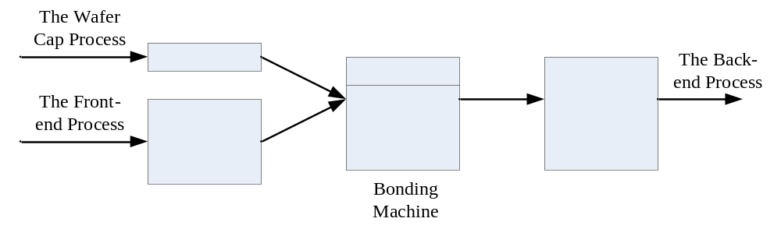
Figure 2 A schematic view of the production process of the accelerometer

Table 3 Operations in the front-end process
Steps No. | Name of the Step
1 | Lot Start
2 | Wafer Scribe
3 | Wafer Scribe Clean
4 | Spin Rinse Dry
5 | Resist Coat
6 | Mask Exposure
7 | Resist Develop
8 | Inspection
9 | Dry Oxide Etch
10 | Wet Resist Strip
11 | Spin Rinse Dry
12 | Inspection
13 | Oxide Deposition
14 | Measurement
15 | Resist Coat
16 | Mask Exposure
17 | Resist Develop
18 | Inspection
19 | Dry Oxide Etch
20 | Wet Resist Strip
21 | Spin Rinse Dry
22 | Inspection
23 | Wet Etch
24 | Spin Rinse Dry
25 | Silicon Trench Etch
26 | Inspection
27 | Wet Etch
28 | Spin Rinse Dry
29 | Inspection
30 | Oxide Deposition
31 | Measurement
32 | Dry Oxide Etch
33 | Measurement
34 | Dry Release Etch
35 | Measurement
36 | Wet Etch
37 | Spin Rinse Dry
38 | Measurement
39 | Pre Furnace Clean
40 | Inspection
41 | Wet Etch
42 | Spin Rinse Dry
43 | Wet Oxidation
44 | Measurement
45 | Pre Furnace Clean
46 | Spin Rinse Dry
47 | Inspection
48 | Oxide Deposition
49 | Measurement
50 | Inspection
51 | Oxide Deposition
52 | Measurement
53 | Resist Coat
54 | Mask Exposure
55 | Resist Develop
56 | Inspection
57 | Dry Oxide Etch
58 | Wet Resist Strip
59 | Spin Rinse Dry
60 | Inspection
61 | Al Clean and Deposition
62 | Resist Coat
63 | Mask Exposure
64 | Resist Develop
65 | Inspection
66 | Measurement
67 | Wet Etch
68 | Spin Rinse Dry
69 | Inspection
70 | Dry Resist Strip
71 | Organic Resist Strip
72 | Spin Rinse Dry
73 | Al Sinter
74 | Inspection
75 | Oxide Deposition
76 | Measurement
77 | Resist Coat
78 | Mask Exposure
79 | Resist Develop
80 | Inspection
81 | Measurement
82 | Wet Etch
83 | Spin Rinse Dry
84 | Inspection
85 | Dry Resist Strip
86 | Organic Resist Strip
87 | Spin Rinse Dry
88 | Inspection
89 | Oxide Deposition
90 | Measurement
91 | Resist Coat
92 | Mask Exposure
93 | Resist Develop
94 | Inspection
95 | Dry Oxide Etch
96 | Measurement
97 | Dry Resist Strip
98 | Organic Resist Strip
99 | Spin Rinse Dry
100 | Inspection
101 | Wet Etch
102 | Spin Rinse Dry
103 | Silicon Trench Etch
104 | Inspection
105 | Wet Etch
106 | Spin Rinse Dry
107 | Record Test Data
108 | Hold

Table 4 Operations in the wafer cap process
Steps No. | Name of the Step
1 | Lot Start
2 | Wafer Scribe
3 | Wafer Scribe Clean
4 | Spin Rinse Dry
5 | Pre Furnace Clean
6 | Wet Etch
7 | Spin Rinse Dry
8 | Thermal Oxide
9 | Measurement
10 | Resist Coat
11 | Hard Brake
12 | Resist Coat
13 | Mask Exposure
14 | Resist Develop
15 | Inspection
16 | Wet Etch
17 | Spin Rinse Dry
18 | Wet Resist Strip
19 | Spin Rinse Dry
20 | Inspection
21 | Silicon Cavities Etch
22 | Spin Rinse Dry
23 | Measurement
24 | Screen Printing
25 | Pre Fire Glass Frit
26 | Hold

Table 5 Operations in the back-end process
Steps No. | Name of the Step
1 | Wafer alignment
2 | Alignment check
3 | Bonding
4 | Record test data
5 | Mount wafer
6 | Bond-pad opening
7 | Remove bond-pad strip
8 | Cleaning
9 | Inspection
10 | Wafer probe
11 | Record test data
12 | Mount wafer
13 | Tape curing
14 | Dicing
15 | Inspection
16 | Sorting
17 | Inspection
18 | Tape and Label
2. 3 The scheduling rules in the Whitmore Fab
Release rules
Release rules dictate as to when to release raw wafers into the production line. Two release rules are used in this fab. One is constant input, i.e., one wafer lot is released into the fab at a constant rate. The other one is Poisson input, i.e., the inter-arrival time of the wafers follows an exponential distribution.
Dispatching rules
In total, six dispatching rules are to be studied:
- FIFO: In this rule, the wafers are dispatched in the same order as they enter the queue.
- CAPFIFO: In this rule, FIFO is applied at all the workstations, except at the workstations which are shared by both the wafer front-end and wafer cap process, in which case priority is given to the wafers in the wafer cap process.
- FRONTFIFO: In this rule, FIFO is applied at all the workstations except at the workstations which are shared by both the wafer front-end and wafer cap process, in which case priority is given to the wafers in the wafer front-end process.
- SRPT (Shortest Remaining Processing Time): In this rule, priority is given to wafers with the least remaining processing time of all the operations not performed.
- CAPSRPT: In this rule, SRPT is applied to all the workstations except at the workstations which are shared by both the wafer front-end and wafer cap process, in which case priority is given to the wafers in the wafer cap process.
- FRONTSRPT: In this rule, SRPT is applied to all the workstations except at the workstations which are shared by both the wafer front-end and wafer cap process, in which case priority is given to the wafers in the wafer front-end process.
3. Questions
3.1 Question 1 (Since AutoSched AP is not available, please just do Question 2).
Given the information above, build the AutoSched AP model incorporating the release rules and dispatching rules. Design the simulation experiments. Which rules achieve the best performance in terms of cycle time?
Hint: It is necessary to make sure that the model has achieved steady state before statistics are collected. Based on historical data, when the release rate is around 0.0775lot/hour, the model is in steady state.
Extra Points: Is there a better way than to release the wafers into the front-end process and the wafer cap process independently?
3.2 Question 2
Given the information above, build the AutoMod model for the front-end process only. Which rules achieve the best performance in terms of cycle time? Also, investigate use of the CONWIP-based job loading polcy and BMI-based job dispatching policy.
Extra Points: Build the AutoMod model for the entire manufacturing process.
4. Procedures
You can work in teams of two. Please submit a brief report summarizing your work and answers to the above questions. This report should also include your simulation model on a CD. Alternately, you may submit your simulation model via the digital drop box.

